NEXTAG COMPANY

Medium suede shoulder bag

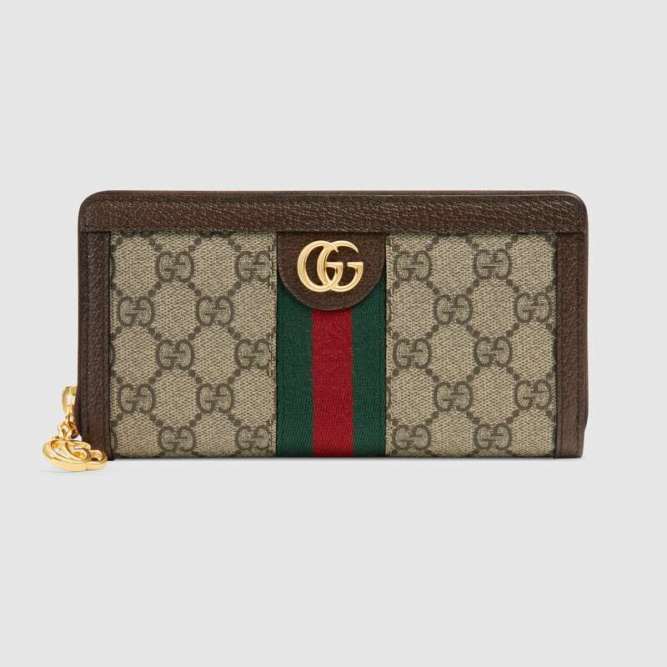

Style # 523154 DJ2DG 8454

Product Description

Influenced by the House's equestrian heritage, this white leather wallet is enhanced by the blue and red Web. Featuring a zip around closure, the accessory is completed by the Double G—an archival detail from the '70s. Blue and red Web • Gold-toned hardware • Ophidia • Double G • Twelve credit card slots and three bill compartments • Zipper coin pocket • Zip around closure • Made in Italy

PRODUCT DETAILS

Style ‎523154 DJ2DG 8454

Influenced by the House's equestrian heritage, this white leather wallet is enhanced by the blue and red Web. Featuring a zip around closure, the accessory is completed by the Double G—an archival detail from the '70s.

* White leather
* Blue and red Web
* Gold-toned hardware
* Moiré lining
* Double G
* Twelve credit card slots and three bill compartments
* Zipper coin pocket
* Zip around closure
* 7.5"W x 4.5"H x 1"D
* Made in Italy